**Universiti Sains Malaysia**

**School of Computer Sciences**

**CAT404 – Software Engineering Major Project**

**Project Proposal - Group Introduction**

[Event Planner System]  
[Project Code]

[Group Name: Upbeat]

| **Student Name** | **Matric Number** | **Subsystem Name** | **Role** |
| --- | --- | --- | --- |
| Nurul Anis Afiqah Binti Mohd Ariff | 148279 | Data Management | **Team Leader** Quality Assurance Analyst |
| Hidayati Itqan Binti Mohd Rosli | 149210 | Dashboard | Architect |
| Nurul Adila Binti Abdul Mukti | 146987 | Order | Requirements Analyst |

**_____________________________________________________________________  
Abstract**

A successful and smooth event is just a dream for every event’s organizer. Considering the hustles that need to be faced to organize an ideal event, the Event Planner System (EPS) is proposed. This web-based system is expected to help clients organize their events faster and conveniently besides having a good experience when booking services online. There are three main user roles that are involved in EPS, which are clients, vendors and admin. The system is then further divided into three subsystems, which are data management subsystem, dashboard subsystem and order subsystem. The Data Management Subsystem is responsible for storing users data, promoting vendors' past projects through catalogs, and delivering excellent user experience to search for services to organize events. The Dashboard Subsystem is responsible for managing the post and advertisement of service packages, filtering service listings through category location or price and lastly it facilitates the booking service by enabling the client to check for vendor’s availability slot. The Order Subsystem is responsible for managing the review process of delivered services, booking process of desired products, tracking the booking progress and managing the payment transaction between clients and vendors. The EPS is designed for a company that can manage online sales and event-related businesses since the nature of the businesses included in this system are food, decor services, photographers, make-up artists, and other related businesses.

*Keywords: Event Planner System, Data Management Subsystem, Dashboard Subsystem, Order Subsystem , Event-related businesses***_____________________________________________________________________**

# **Project Background**

E-commerce has emerged as an important industry and sector in recent years, particularly since the world slowly recovers from the COVID-19 pandemic. More people are shifting their preferences toward using an ecommerce platform to manage their daily needs. E-commerce includes not only purchasing and selling of goods, but also providing services. Every event service has its own booking platform, whereas some local businesses only deal with customers through social media to reduce the cost of having their own platform. Services necessary for an event like the perfect birthday party or weddings are frequently scattered; each has its own platform for booking services, requiring users to search multiple sites to find their preferred service. This had caused the booking and surveying process become time consuming. Thus, a project called Event Planner System (EPS) is proposed as a business-to-consumer e-commerce system that gathers event-related services in one platform and sells the goods or services to an individual consumer. This web-based system is expected to help clients organize their events more quickly and easily besides assisting users in having a good experience when booking services online.

# **Proposed System Introduction**

## **System Overview**

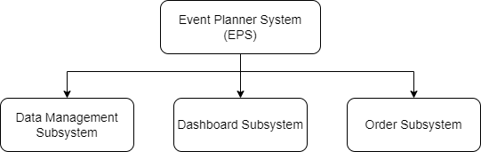

*Diagram 1 shows the System Overview*

Event Planner System (EPS) is a web based system that will be developed to achieve the objectives of this project. There are three main user roles that are involved in EPS, which are clients, vendors and admin. The administrator is responsible for managing user data in the system, whereas vendors will use the system to sell their services and attract clients. The client, who is the primary user of the EPS may search for and book any services available.

The EPS is divided into 3 subsystems; data management subsystem, dashboard subsystem and order subsystem. First, the Data Management Subsystem is responsible for storing users data, promoting vendors' past projects through catalogs, and delivering excellent user experience to search for services to organize events. Second, the Dashboard Subsystem is responsible for managing the post and advertisement of service packages, filtering service listings through category location or price and lastly it facilitates the booking service by enabling the client to check for vendor’s availability slot. Lastly, the Order Subsystem is responsible for managing the review process of delivered services, booking process of desired products, tracking the booking progress and managing the payment transaction between clients and vendors.

**2.1.1 Subsystem Overview**

The objectives of each subsystem are listed below:

1. Subsystem 1: Data Management

* Manage users of the system (admin/client/vendor).
* Manage the services offered by the vendor and feedback by the clients.
* Manage the complaint/issue raised by the clients.

1. Subsystem 2: Dashboard

* Manage advertisement/services registered to the system.
* Manage the availability of the services provided.
* Manage the service listing through preference of the client.

1. Subsystem 3: Order

* View, book and modify the services offered by the vendor in the cart.
* Make a payment for the service selected.
* Manage the booking and feedback review.

## **Proposed Features**

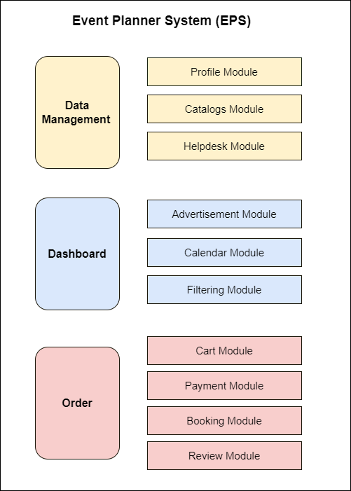

*Diagram 2 shows the Module Diagram of Event Planner System (EPS)*

These are the proposed features of the Event Planner System:

1. Subsystem 1: Data Management

Profile Module

* The admin/client/vendor can register an account.
* The admin/client/vendor will be able to login to the system.
* The client/vendor can update the profile page.
* The system will store all users information.

Catalog Module

* The vendor will be able to upload photos or videos related to past projects as service catalogs.
* The clients can review service details.
* The system will store all details of the service catalogs.

Helpdesk Module

* The user can ask admin any questions related to issues encountered.
* The admin will be able to reply to users’ questions.
* The user can review a set of questions related to the system.
* The system will be able to list all questions frequently asked by users.

1. Subsystem 2: Dashboard

Advertisement Module:

* The vendor can add, edit and delete advertisements to advertise their service or product by providing a full description of the service.
* The client can view the post that has been made by the vendor.
* The client can book the service or product by filling in the booking form.
* The vendor can review the booking form by the client before confirming or rejecting the booking.
* The admin can manage the advertisement posted by the vendors.

Calendar Module:

* The vendor can update and edit the calendar on which date he/she is available and not available for the service/product.
* The client can refer to the calendar before proceeding to order the service/product.

Filtering Module:

* The client can search for her/his desired service/product.
* The client can filter the services by category, location and price.
* The admin can manage the filtering data.

1. Subsystem 3: Order

Cart Module

* The customer will be able to add interested service to cart
* The customer will be able to edit quantity or item in the cart
* The customer will be able to remove the item in the cart
* The customer will be able to see the item’s quantity and price in the cart.
* The admin will be able to manage all cart data.

Payment Module

* The customer will be able to make payment to the vendor.
* The vendor will be able to receive the status of the payment made by the customer.
* The admin will be able to approve the payment release to the vendor once the service confirmation is made by the customer.

Booking Module

* The customer will be able to check the booking progress whether it is accepted or rejected by the vendor.
* The vendor will be able to view the book request from the customer.
* The vendor will be able to accept or reject the book request from the customer.

Review Module

* The customer will be able to put their review once the service is confirmed.
* The vendor will be able to view all the reviews received.
* The admin will be able to manage all the review data.

### **Subsystem Overview**

Data Management Subsystem is responsible for storing users data and delivering some features to enhance user experience when searching for services to organize events. This subsystem is made up of three modules that deliver system functionality: the profile module, catalogs module and helpdesk module. First, the profile module manages each user’s account. Each user of the Event Planner System must register and login before utilizing the system in order to book any services. Thus, the profile module will allow each user to create an account by filling out necessary information. After creating an account, users can access all features offered inside the system. Authorization process for accounts created also will be implemented inside this module. Second, the catalogs module offered the vendors to promote their services by displaying photos or videos on their main page inside the system. This feature will enable vendors to upload any media related to their past projects to their page in order to prove their skills. Third, the helpdesk module will allow administrators to engage in an open conversation with users about any issues that arise. Admin can respond to user questions, and users can provide feedback on the assistance provided. Inside this module also will have a listing of common questions regarding the system for each user to refer and follow.

The second subsystem is Dashboard Subsystem. Dashboard subsystem consists of 3 modules which are advertisement module, calendar module and filtering module. The main activity of the client and vendor in the system happens in this subsystem. In advertisement module, the vendor needs to post the advertisement of his/her services or products with full descriptions and photos. He/she will be able to edit or delete the ads later. Next, the client can view the ads in a view of the gallery on their dashboard. If the client wants to book the service or product, they need to click “Book” button and fill in the booking form provided. The form consists of related info about the event being conducted such as the date, the theme, the number of guests, etc. Lastly, the vendor will receive the booking form and will be able to review the form before proceeding to accept or reject the booking depending on her/his schedule. The second module is calendar module. This module specifies the vendor’s schedule. He/she can update the calendar when the service is already booked on a certain date so that the clients can refer to the calendar before deciding to fill in the booking form. The third module is filtering module which allows the client to choose either to search for their desired services or products by category, location or price. This will help them to find the service or product faster.

Lastly, the Order Subsystem is made up of four modules where each module will have its own responsibility in contributing towards the meaningful overall solution. Starting with the cart module, the customer will be able to add the interested service from post listing into the cart. Once added, the customer will be able to come back and check for the interested service straight from the cart. They will be able to edit the quantity or remove item in the cart. The admin will be able to manage cart data. Next, in the payment module, the customer will be able to make payment to vendor to book the service while the vendor will be able to receive the payment made by the customer once service receival is confirmed. Furthermore, in this module, the admin will also be able to manage all payment data and approve the payment release to the vendor once the service confirmation made by the customer. The third module is booking module. In this module, the customer will be able to check the booking progress whether it is accepted or rejected by the vendor. The vendor will be able to view the booking request from customer and accept or reject the booking request from customer based on their availability on the requested date and time. Lastly, in review module, the customer will be able to put their review upon the service received confirmation is made and the vendor will be able to view all the review received.

## **Organization Background**

The Event Planner System (EPS) is designed for a company that can manage online sales and event-related businesses since the nature of the businesses included in this system are food, decor services, photographers, make-up artists, and other related businesses. The future owner of this system will be from an e-commerce company field that specializes in providing service to the client. The system allows the vendors to advertise their business by posting the advertisements of their services/products. The listing of the services is displayed at the dashboard. Next, the clients can browse the dashboard and find their desired services/products using the filtering feature. In addition, the clients may add the services/products into their cart before proceeding to book and pay for the services/products.

Some of the benefits that can be obtained through this system are:

* Help the vendor by reducing the cost needed to market their service.
* Provide the vendor with a wider customer base across the internet user.
* Enable the client to save more time and easier to make comparisons between services.
* Provide the client with various service choices and flexible booking time.
* Protect the client and the vendor from facing scamming issues or last minute booking cancellation.
* Help the admin in facilitating the data management of the system.
* Provide sustainable profit to the company by collecting commission from each service transaction.